Forever Jak (GDD)



***‘No Way Home’*** - Ariel Rowel Pingol, Steven Nguyen, Alex Ilinykh, Cole Beezley

This page: Table of Contents and Team Member Listing

| Table of Contents  [1 Game Overview](https://n-xovwktmtjsnaxyc2mwes2xu7pohqedmdm6zjw5q-2lu-script.googleusercontent.com/userCodeAppPanel)  [2 High Concept](https://n-xovwktmtjsnaxyc2mwes2xu7pohqedmdm6zjw5q-2lu-script.googleusercontent.com/userCodeAppPanel) / Genre  [3 Unique Selling Points](https://n-xovwktmtjsnaxyc2mwes2xu7pohqedmdm6zjw5q-2lu-script.googleusercontent.com/userCodeAppPanel)  [4 Platform Minimum Requirements](https://n-xovwktmtjsnaxyc2mwes2xu7pohqedmdm6zjw5q-2lu-script.googleusercontent.com/userCodeAppPanel)  [5 Competitors / Similar Titles](https://n-xovwktmtjsnaxyc2mwes2xu7pohqedmdm6zjw5q-2lu-script.googleusercontent.com/userCodeAppPanel)  [6 Synopsis](https://n-xovwktmtjsnaxyc2mwes2xu7pohqedmdm6zjw5q-2lu-script.googleusercontent.com/userCodeAppPanel)  [7 Game Objectives](https://n-xovwktmtjsnaxyc2mwes2xu7pohqedmdm6zjw5q-2lu-script.googleusercontent.com/userCodeAppPanel)  [8 Game Rules](https://n-xovwktmtjsnaxyc2mwes2xu7pohqedmdm6zjw5q-2lu-script.googleusercontent.com/userCodeAppPanel)  [9 Game Structure](https://n-xovwktmtjsnaxyc2mwes2xu7pohqedmdm6zjw5q-2lu-script.googleusercontent.com/userCodeAppPanel)  [10 Game Play](https://n-xovwktmtjsnaxyc2mwes2xu7pohqedmdm6zjw5q-2lu-script.googleusercontent.com/userCodeAppPanel)  [10.1 Game Controls](https://n-xovwktmtjsnaxyc2mwes2xu7pohqedmdm6zjw5q-2lu-script.googleusercontent.com/userCodeAppPanel)  [10.2 Game Camera](https://n-xovwktmtjsnaxyc2mwes2xu7pohqedmdm6zjw5q-2lu-script.googleusercontent.com/userCodeAppPanel)  [10.2.1 HUD](https://n-xovwktmtjsnaxyc2mwes2xu7pohqedmdm6zjw5q-2lu-script.googleusercontent.com/userCodeAppPanel)  [10.2.2 Maps](https://n-xovwktmtjsnaxyc2mwes2xu7pohqedmdm6zjw5q-2lu-script.googleusercontent.com/userCodeAppPanel)  [11 Players](https://n-xovwktmtjsnaxyc2mwes2xu7pohqedmdm6zjw5q-2lu-script.googleusercontent.com/userCodeAppPanel)  [11.1 Characters](https://n-xovwktmtjsnaxyc2mwes2xu7pohqedmdm6zjw5q-2lu-script.googleusercontent.com/userCodeAppPanel)  [11.2 Metrics](https://n-xovwktmtjsnaxyc2mwes2xu7pohqedmdm6zjw5q-2lu-script.googleusercontent.com/userCodeAppPanel)  [11.3 States](https://n-xovwktmtjsnaxyc2mwes2xu7pohqedmdm6zjw5q-2lu-script.googleusercontent.com/userCodeAppPanel)  [11.4 Weapons](https://n-xovwktmtjsnaxyc2mwes2xu7pohqedmdm6zjw5q-2lu-script.googleusercontent.com/userCodeAppPanel)  [12 Player Line-up](https://n-xovwktmtjsnaxyc2mwes2xu7pohqedmdm6zjw5q-2lu-script.googleusercontent.com/userCodeAppPanel)  [13 NPC](https://n-xovwktmtjsnaxyc2mwes2xu7pohqedmdm6zjw5q-2lu-script.googleusercontent.com/userCodeAppPanel)  [13.1 Enemies](https://n-xovwktmtjsnaxyc2mwes2xu7pohqedmdm6zjw5q-2lu-script.googleusercontent.com/userCodeAppPanel)  [13.1.1 Enemy States](https://n-xovwktmtjsnaxyc2mwes2xu7pohqedmdm6zjw5q-2lu-script.googleusercontent.com/userCodeAppPanel)  [13.1.2 Enemy Spawn Points](https://n-xovwktmtjsnaxyc2mwes2xu7pohqedmdm6zjw5q-2lu-script.googleusercontent.com/userCodeAppPanel)  [14 Art](https://n-xovwktmtjsnaxyc2mwes2xu7pohqedmdm6zjw5q-2lu-script.googleusercontent.com/userCodeAppPanel)  [14.1 Setting](https://n-xovwktmtjsnaxyc2mwes2xu7pohqedmdm6zjw5q-2lu-script.googleusercontent.com/userCodeAppPanel)  [14.2 Level Design](https://n-xovwktmtjsnaxyc2mwes2xu7pohqedmdm6zjw5q-2lu-script.googleusercontent.com/userCodeAppPanel)  [14.3 Audio](https://n-xovwktmtjsnaxyc2mwes2xu7pohqedmdm6zjw5q-2lu-script.googleusercontent.com/userCodeAppPanel)  [15 Procedurally Generated Content](https://n-xovwktmtjsnaxyc2mwes2xu7pohqedmdm6zjw5q-2lu-script.googleusercontent.com/userCodeAppPanel)  [15.1 Environment](https://n-xovwktmtjsnaxyc2mwes2xu7pohqedmdm6zjw5q-2lu-script.googleusercontent.com/userCodeAppPanel)  [15.2 Levels](https://n-xovwktmtjsnaxyc2mwes2xu7pohqedmdm6zjw5q-2lu-script.googleusercontent.com/userCodeAppPanel)  [15.3 Artificial Intelligence NPC](https://n-xovwktmtjsnaxyc2mwes2xu7pohqedmdm6zjw5q-2lu-script.googleusercontent.com/userCodeAppPanel)  [15.4 Visual Arts](https://n-xovwktmtjsnaxyc2mwes2xu7pohqedmdm6zjw5q-2lu-script.googleusercontent.com/userCodeAppPanel)  [15.5 Audio](https://n-xovwktmtjsnaxyc2mwes2xu7pohqedmdm6zjw5q-2lu-script.googleusercontent.com/userCodeAppPanel)  [15.6 Minimum Viable Product (MPV)](https://n-xovwktmtjsnaxyc2mwes2xu7pohqedmdm6zjw5q-2lu-script.googleusercontent.com/userCodeAppPanel)  [16 Wish List](https://n-xovwktmtjsnaxyc2mwes2xu7pohqedmdm6zjw5q-2lu-script.googleusercontent.com/userCodeAppPanel)  17 Bibliography   |  | | --- | | Game Development Team Members    PRODUCER  Ariel Rowel Pingol, Steven Nguyen, Alex Ilinykh, Cole Beezley    PRODUCTION MANAGER  Ariel Rowel Pingol, Steven Nguyen, Alex Ilinykh, Cole Beezley    PRODUCTION COORDINATOR  Ariel Rowel Pingol, Steven Nguyen, Alex Ilinykh, Cole Beezley  GAME DESIGNERS  Ariel Rowel Pingol, Steven Nguyen, Alex Ilinykh, Cole Beezley  SYSTEMS/IT COORDINATOR  Ariel Rowel Pingol, Steven Nguyen, Alex Ilinykh, Cole Beezley  PROGRAMMERS  Ariel Rowel Pingol, Steven Nguyen, Alex Ilinykh, Cole Beezley  TECHNICAL ARTISTS  Ariel Rowel Pingol, Steven Nguyen, Alex Ilinykh, Cole Beezley  AUDIO ENGINEERS  Ariel Rowel Pingol, Steven Nguyen, Alex Ilinykh, Cole Beezley  UX TESTERS  Ariel Rowel Pingol, Steven Nguyen, Alex Ilinykh, Cole Beezley |
| --- | --- | --- |

|  |
| --- |

# 1 Game Overview

Title: Forever Jak

Platform: PC Standalone

Genre: Action-Adventure

Rating: (10+) ESRB

Target: Casual gamer (aging from 12 - 30)

Release date: November 2021

Publisher: Rowel Technologies

Description: Forever Jak is an Action-Adventure game in which the player controls a character named Jak. Jak is located in a maze of zombies and needs to find his way out. To help Jak escape the maze of zombies, Jak must try to reach the end of the maze while collecting treasures and dodging evil humanoids. If Jak does not find his way out, he will be stuck forever. The humanoids are hindering Jak’s only chance to find his way home. Help Jak find his way home!

# 2 High Concept / Genre

Forever Jak sets the Player in a Maze Forest where the character Jak must find his way towards the end of the maze to escape. Jak must avoid evil zombies as they are hindering his way back home. Bring Jak Home!

# 3 Unique Selling Points

* Engaging level design
* Unique gameplay
* Wholesome story

# 4 Platform Minimum Requirements

PC, MAC AND LINUX STANDALONE

OS: Windows 7 SP1+, Mac OS X 10 .13+, Ubuntu 20 .04+

Graphics card: DX10, DX11, and DX12-capable GPUs; generally,

everything made since 2009 should work

# 

# 5 Competitors / Similar Titles

Jak and Daxter

Tomb Raider

Assassins Creed

Quake

The Last of Us

# 6 Synopsis

Jak has become lost in a valley of nightmares -- with your guidance, he must fight his way through hordes of zombies and trials to escape the valley of nightmares, and find his way home.

# 7 Game Objectives

The objective of the game is to dodge through the zombies without getting hurt, and find your way out of the maze.

# 8 Game Rules

The game is a closed level design within a set space, the maze of zombies. The zombies are going to be spawning in set locations within this maze, and the player can navigate through the zombies. Each zombie will try to attack the player and destroy Jak, and it is the player's goal to dodge the zombies in order to survive.

# 9 Game Structure

The player spawns in a valley and must search for an exit, while avoiding zombies that get in his way. The player starts at character selection, starts playing the level, and then either dies and restarts, or completes the game and goes to the credits screen.

# 10 Game Play

## 

## 10.1 Game Controls

Move Camera: Mouse rotation

Walk Forward: W Key

Run: W Key + Left Shift

## 10.2 Game Camera

The Game Camera follows the main player around in a third person perspective.

### 10.2.1 HUD

Coin Counter - Represents how many coins Jak has.

### 10.2.2 Maps

There is one map, the maze of zombies that Jak must navigate and escape -- filled with treacherous enemies, a luscious forest, and brush surrounding it. It is located within a valley.

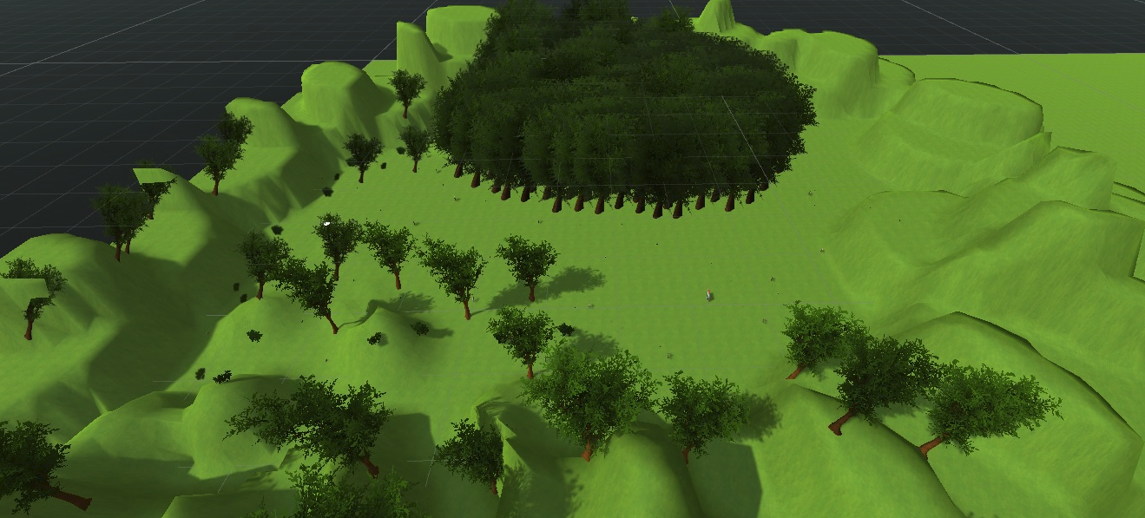

# 11 Players

The setting takes place in a maze of zombies where the main character is a person named Jak. Jak is trying to escape the maze of zombies but little does he know there are zombies trying to chase after him while he is in the process of collecting coins.

## 11.1 Characters

Jak - Jak lives in a wonderful world. When Jak is currently on a mission, the valley that he is adventuring through is in disarray. The problem was the citizens of the valley became zombified.

## 11.2 Metrics

* Speed: 10
* Max Health: 100
* Attack Damage: N/A
* Time to Attack: N/A

## 11.3 States

* Idle: An idle state animation where Jak is relaxed and waiting.
* Move: A movement animation of Jak walking forward.
* Run: A running animation of Jak sprinting.

# 12 Player Line-up

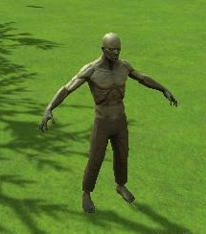

# 13 NPC

## 13.1 Enemies

* Running Zombie
  + Speed: 1 - 1.8 (depending on difficulty)
  + Attack Time: Instant
* Walking Zombie
  + Speed: 1
  + Attack Time: Instant

### 13.1.1 Enemy States

Move: The enemies animation when they are moving towards Jak to attack

Attack: The enemy ‘attacks’ Jak and raises their hands up.

### 13.1.2 Enemy Spawn Points

There are set spawn points within the valley that enemies will be spawned at, generally

in the forward direction of Jak and blocking him from reaching the end.

The Running Zombies (faster) spawn mostly further away, while the Walking Zombie (slower) tend to spawn closer.

# 14 Art

## 14.1 Setting

The setting is a nice natural meadow with trees, shrubbery, and a zombie outbreak located within a valley. The art style is reflected by the models we chose for aspects within the valley, the lighting, and the skybox present.

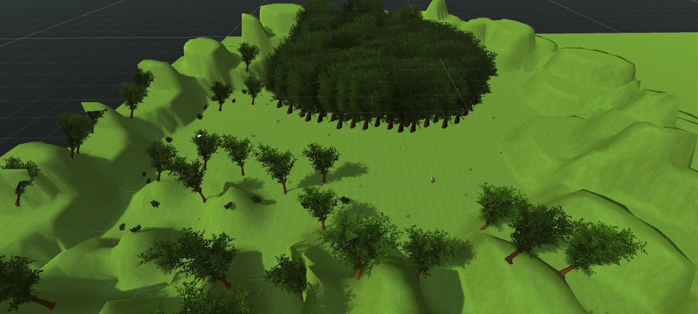

## 14.2 Level Design

The level design is the player starting at one end of the meadow, and having to navigate through the forest and horde of zombies to reach the end and escape the zombies. The level design art was built into unity and the models taken from the Asset Store. The coins present throughout the level were also taken from the Asset Store.

## 14.3 Audio

Name: Jak & Daxter Soundtrack - Track 04 - Geyser Rock

Category: Background Music

Description: Plays during the game.

Name: Coin Sound (World of Warcraft)

Category: FX

Description: Plays when a coin is collected.

# 15 Procedurally Generated Content

## 15.1 Environment

The Environment was downloaded from the Unity Asset Store. The location of each asset, such as the trees, mountains, and coins were all placed by us.

## 15.2 Levels

There are two different levels. Easy and Normal. In the Easy difficulty level, the player will face slower speed zombies with a speed of 1 for the zombies. If the player chooses Normal as a difficulty level, the zombies speed is set to 1.8.

## 15.3 Artificial Intelligence NPC

Implemented the ability for the zombies to find the shortest path to the Player. The zombie A Star Pathfinding code is used to track where the main player is currently located relative to the zombie’s location.

## 15.4 Visual Arts

The visual arts, located in the main menu, created are original art that the programmer made. The visual art was meant to immerse the player to feel like they are in Sci-Fi world. These arts were customized to make the world feel dynamic.

The visual art was implemented in the main menu. The visual art was edited on adobe photoshop.

## 15.5 Audio

No audio was created by us. Refer to Bibliography for source.

## 15.6 Minimum Viable Product (MPV)

• One Player character to choose from (Jak)

• Built for the PC platform

# 16 Wish List

**Add Weapons**

Jak in the future may have weapons to choose from to kill the zombies as well as different damage ratios for each weapon.

**Add More Enemies**

Have animals that try to get Jak too. Such as wolves or birds.

**Add More Levels**

The future levels will have different level designs as well has different obstacles to overcome.

**Add More to Storyline**

Explain the background of Jak and how he got himself into the current scenario to escape. Moreover, upon entering the portal it would send him back to his hometown where the citizens of his hometown are also in disarray. He must fight to restore balance in his home.

**Add Allies**

I would like to add characters from the Jak & Daxter series incorporated into this video game.

## 17 Bibliography

**Youtube Video Resources:**

“How to Animate Characters in Unity 3D | Animator Explained.” *YouTube*, IHeartGameDev, 31 May 2020, https://www.youtube.com/watch?v=vApG8aYD5aI&ab_channel=iHeartGameDev.

Brackeys. “Third Person Movement in Unity.” *YouTube*, Brackeys, 24 May 2020, https://www.youtube.com/watch?v=4HpC--2iowE&ab_channel=Brackeys.

“How to Import Character Model into Unity.” *YouTube*, Fui, 9 July 2020, https://www.youtube.com/watch?v=Q8lJpoUwaBA&ab_channel=Fui.

“Unity 3D How to Create a Terrain, Add Trees and Grass.” *YouTube*, A Webdesign, 25 Apr. 2020, https://www.youtube.com/watch?v=7vFZKLcK3aA&ab_channel=AWebdesign.

“How to Animate Characters in Unity 3D | Animation Transitions With Booleans.” *YouTube*, IHeartGameDev, 28 June 2020, https://www.youtube.com/?app=desktop.

“How to Change the Skybox in Unity.” *YouTube*, XyloBeta, 15 Aug. 2020, https://www.youtube.com/?app=desktop.

**Assets:**

Jeffrey Fan. “Jak - Download Free 3D Model by Jeffrey Fan 2000.” *Sketchfab*, Jeffrey Fan 2000, 1 June 1969, https://sketchfab.com/3d-models/jak-307b59407ea943b3ac57445551439e88.

*Mixamo*, https://www.mixamo.com/#/?page=1&query=idle+gun&type=Motion%2CMotionPack.

“Dream Forest Tree: 3d Trees.” *Unity Asset Store*, IL.ranch, https://assetstore.unity.com/packages/3d/vegetation/trees/dream-forest-tree-105297.

**Splash Screen:**

“Create Custom Logos with Designevo Free Logo Maker.” *Designevo.com*,<https://www.designevo.com/>.

**Roles**

**Ariel**:

1. Worked on the menu
2. control button
3. added the terrain default floor
4. imported a object character
5. set up the camera to follow character
6. wrote some c# code to handle character movements
7. used mixamo to gather character animations.
8. Created the character object and animation for the player.
9. Created the terrains, tree, grass, and Maze design

**Steven**:

1. Developed Jak’s movement.
2. Created Jak’s Animations for Walking, Running, and etc.
3. Created the Sky.

**Alex**:

1. Created Coins + Added Coin Sound effect
2. Added In-Game Spawn Color

**Cole**:

1. Added enemy AI/model/animations
2. Added exit portal
3. Added terrain
4. Worked on menu, (optimizing buttons, adding scenes)